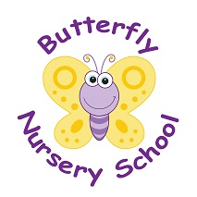
Butterfly Nursery School
Church Road
Horne
Surrey
RH6 9LA
01342 843655
POLICY: No Smoking Policy (EYFS: 3.55)

Children’s health and well –being is of the upmost importance for the nursery. Smoking has proved to be a health risk and therefore in accordance with legislation, the nursery operates a strict no smoking policy within its buildings and grounds. It is illegal to smoke in enclosed places.

You are respectfully required to abstain from smoking whilst on the premises. This rule also applies to staff, students, parents, carers, visitors, contractors etc.
Staff accompanying children outside the nursery are not permitted to smoke. We also request that parents accompanying children on outings refrain from smoking whilst caring for the children.

Staff must not smoke whilst wearing nursery uniform as it is essential that staff are positive role models to children and promote a healthy lifestyle. If staff choose to smoke during
Breaks they are asked to change in to their own clothing and smoke away from the main entrance.

We respect that it is a personal choice to smoke, although as an organisation we support healthy lifestyles and therefore help staff and parents to stop smoking by:
- Providing factsheets and leaflets
- Providing information of local help groups
- Providing details of the NHS quit smoking helpline – www.smokefree.nhs.uk
- Offering information regarding products that are available to help stop smoking.
- Offering in- house support

This policy was adopted on | Signed on behalf of the nursery | Date disseminated to staff | Date for review

